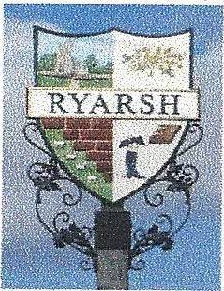

DEFIBRILLATOR TRAINING

THERE WILL BE A DEFIBRILLATOR TRAINING SESSION AT THE VILLAGE HALL ON
SUNDAY SEPTEMBER 19TH AT 11 AM.
PLACES ARE LIMITED AND IF OVERSUBSCRIBED MORE SESSIONS WILL BE ARRANGED. PLEASE BOOK YOUR PLACE BY EMAILING : ryarshbookings@gmail.com
LEARN HOW TO SAVE A LIFE
