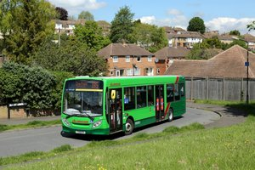
Nu Venture Bus Service

Kent County Council Support for buses 58 and 70 ended on 12th February 2023, and school-time buses 558 and 578 also cease to serve the Malling area.

However, until July 2023, Nu Venture will continue to operate a limited replacement daytime service on certain days of the week. Parish Councils are helping to fund this service. The 58 Bus Service for Ryarsh is on a Friday.

PLEASE USE IT OR LOSE IT

Continuation beyond July 2023 will be dependent on usage in coming months.
The number 58 Friday Bus Service leaves Ryarsh opposite Duke of Wellington at 10.08.
The service stops at Leybourne, West Malling High Street opposite Tesco, East Malling King and Queen, Larkfield opposite Wealden Hall, Hall Road opposite Sainsburys and Maidstone Town Centre.
The return service leaves Maidstone at 13.00 and arrives in Ryarsh at 13.48.

The full timetable is available at www.nu-venture.online/bus-times

