Newsletter  Summer 2023 | 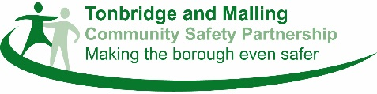

Welcome

Welcome to this edition of the Tonbridge and Malling Community Safety Partnership (CSP) newsletter. The aim of the newsletter is to provide regular updates on some of the work of the Community Safety Partnership.

In this edition you’ll find details about our priorities for the year ahead, keeping safe in water, information about our mobile CCTV cameras and details of events we’ll be attending during the summer.

For further details about any of these items please contact Alison Finch, Safer & Stronger Communities Manager on Alison.finch@tmbc.gov.uk or Anthony Garnett, Head of Service, Licensing, Community Safety and Customer Service (Anthony.garnett@tmbc.gov.uk).
________________________________________
Community Safety Partnership Priorities for 2023/24

The Community Safety Partnership (CSP) has now agreed its priorities for 2023/24 and has decided to focus on tackling:

- Anti-Social Behaviour – including environmental crime.
- Vulnerable people – including mental health, child criminal sexual exploitation, gangs, modern slavery and human trafficking, substance misuse and youth diversion.
- Tackling violent crime – including Serious Violent Crime, Violence Against Women and Girls and Stalking
- Domestic Abuse
- Preventing Extremism and Hate

Actions have been set to address key areas within these priorities and these will be monitored over the year. Actions include:

- Working with domestic abuse organisations to help support victims of domestic abuse.
- Putting diversionary activities in place to help prevent young people from becoming involved in anti-social behaviour.
- Working with Mediation services to help prevent neighbour disputes from escalating.
- Working with Kent Police and Tonbridge & Malling Borough Council to stop flytipping.
- Identifying individuals who may be at risk of being drawn into extremism and referring them to appropriate support.

The Community Safety Partnership will use crime statistics to measure how effective they are and look at where more resources need to be targeted. Currently crime levels show that Tonbridge & Malling remains one of the lowest in Kent and we want to continue this throughout the year ahead.

If you would like a copy of the Community Safety Partnership Plan for 2022/23 which sets out our priorities and action plan then please contact csp@tmbc.gov.uk

Water Safety
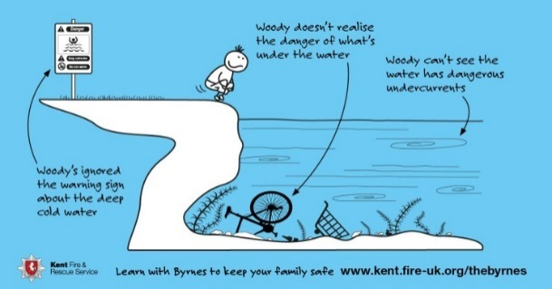 | At this time of the year (and particularly in the warm weather) it can be very tempting to jump into lakes and rivers; however, the water may look safe but can be dangerous. Outdoor water is very cold and can quickly cause cramp and breathing difficulties. It is often far deeper than people think and there may be hidden currents. There may also be hidden underwater hazards and weeds that can cause entanglement that cannot be seen from land. It can also be difficult to get out.
The CSP doesn’t want to spoil anyone’s fun but we do want to make sure that everyone stays safe. Please don’t jump into water when you don’t know how deep it is. In two of the Country Parks in Tonbridge & Malling (Leybourne Lakes and Haysden Country Park in Tonbridge) and at Holborough Lakes and Tonbridge Locks unauthorised swimming is prohibited, and you could be given an £100 fine if you are seen in the water.

Neighbourhood Engagement meetings
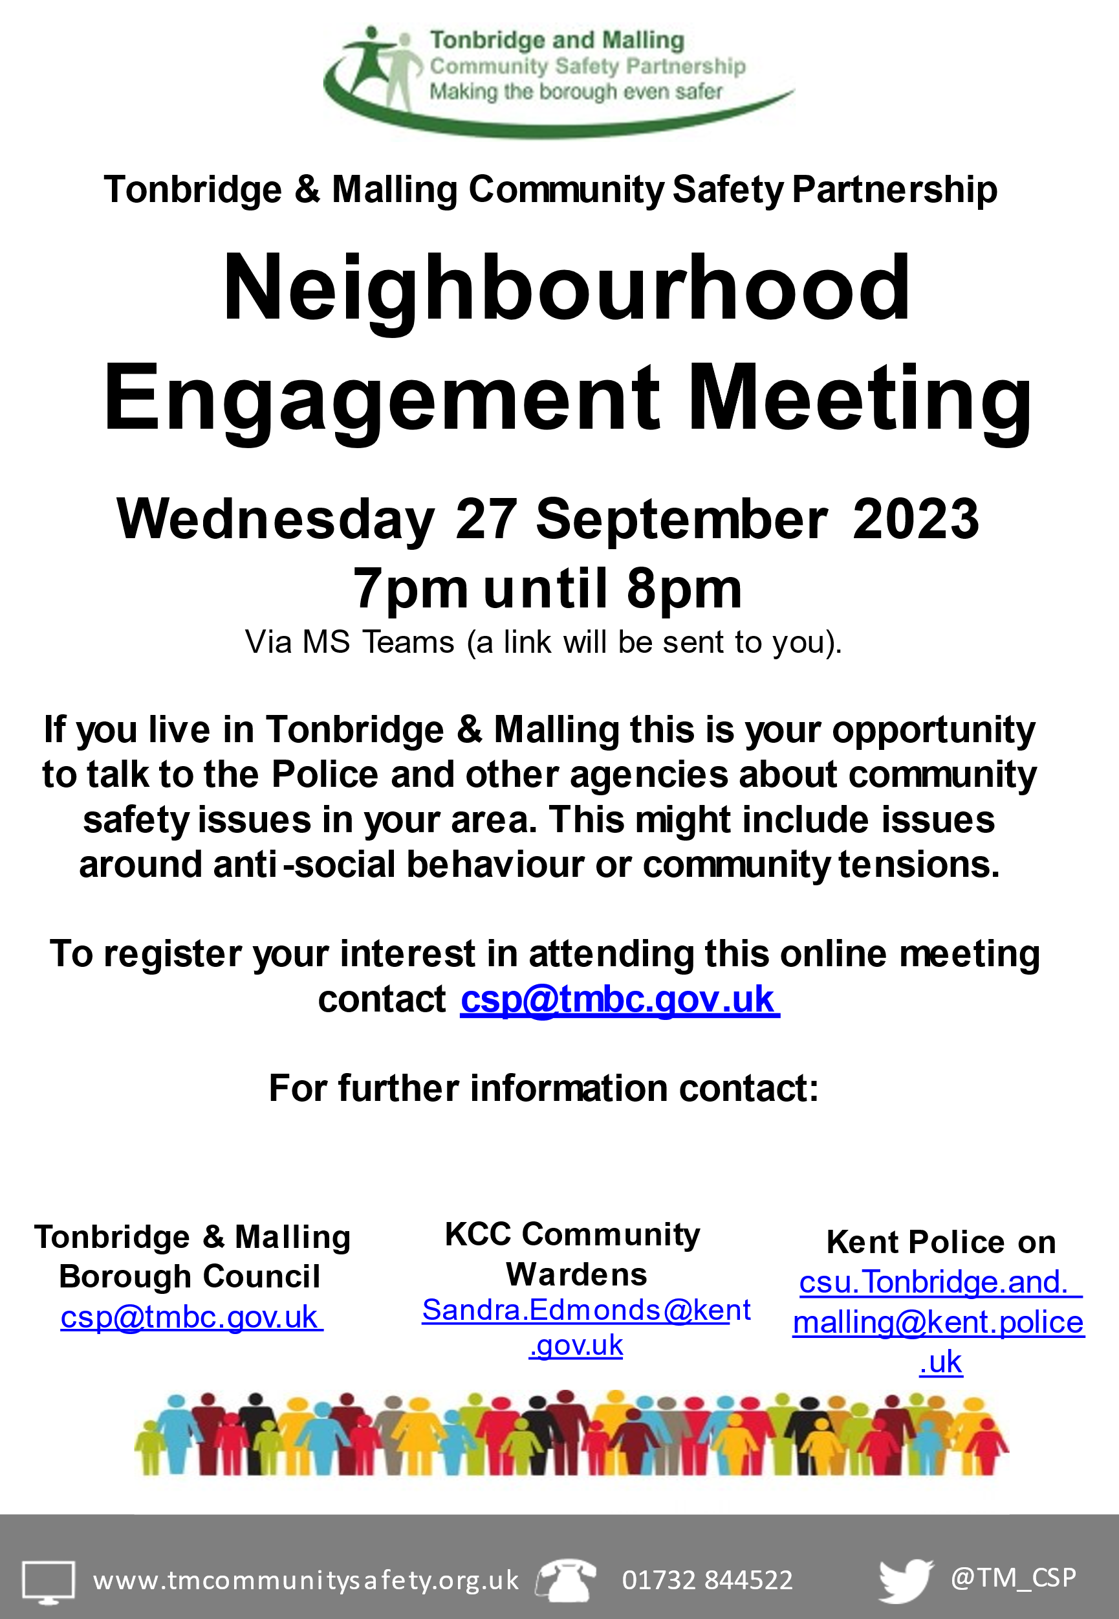 | The Community Safety Partnership will be continuing to hold Neighbourhood Engagement meetings throughout 2023.  The aim of the meetings are to allow residents the chance to talk to Kent Police, Kent County Council and Borough Council representatives about community safety issues of concern (i.e. anti-social behaviour, criminal activities etc.) and then the representatives can look at any appropriate actions that can be taken to address these issues.  The next meeting for 2023 will be held on Wednesday 27 September. It will start at 7pm and will be held via Microsoft Teams. If you would like to attend the meeting, please email csp@tmbc.gov.uk to register your interest.  We’ll also be running community drop in events during 2023 – and further details about these are on page 4.

Re-deployable CCTV Cameras

The Borough Council was recently successful in receiving funding from the Government through the UK Shared Prosperity Fund to purchase four re-deployable CCTV cameras. The aim of these is to place them in areas across the borough where there is anti-social behaviour such as ongoing neighbour disputes or flytipping. The images recorded can then be reviewed and action can be taken if anything is seen. The cameras will remain in place for a few months at a time before being moved to new locations.

__________________________________________
Shed burglaries

At this time of year burglaries to sheds or other outbuildings can increase. Make sure that you keep your shed secure by:
- Installing a shed alarm, with a notice displayed to warn thieves that it is not worth the effort of breaking in. The alarms are easy to install and can be purchased at most DIY stores.
- Make sure the door is securely locked at all times.
- Ensure all valuable property is marked with your postcode. Post coding property makes your belongings very unattractive to a thief by making items easily identifiable and difficult to sell.
- Lock up pedal cycles. Use bike locks and chain them inside to other large items or to the shed.
- Keep a record of the make, model and ID numbers of bicycles and all other equipment and take photographs of unusual items. You can use www.immobilise.com to record your items. This is free to use and helps the Police to identify owners of recovered property.

Getting help with anti-social behaviour.

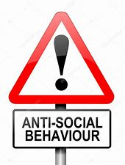 | Tackling anti-social behaviour is a key priority for the Community Safety Partnership and there are a variety of different ways for people who are experiencing anti-social behaviour (ASB) to report this to agencies who can help resolve their issues.  If you are a housing association tenant, please first report your anti-social behaviour directly to them – you’ll find details on their websites.  Tonbridge & Malling Borough Council have an online reporting form Help tackle crime and anti-social behaviour – Tonbridge and Malling Borough Council (tmbc.gov.uk) or you can call 01732 844522.
You can report noise issues directly to the Borough Council’s Noise team Report noise, odours or pollution – Tonbridge and Malling Borough Council (tmbc.gov.uk)
Kent Police also have an online reporting form How to report antisocial behaviour | Kent Police or you can phone 101 in a non-emergency or 999 in an emergency.
If your anti-social behaviour is continuing and you have reported at least three incidents of anti-social behaviour to a relevant organisation (e.g. the Council, Police, Social Landlord) within the previous six months and these are incidents where the same behaviour, nuisance or problem has reoccurred and where you feel that no effective action has been taken then you can apply for a Community Trigger.

If your application meets the threshold, then a Review Panel would be held to discuss your case and look at whether any further actions could or should be taken. You would be kept informed during this process. Further details about the Community Trigger and how to apply can be found at www.tmbc.gov.uk
__________________________________________
Community Safety Events

The Community Safety Partnership will be running some Community Safety stands during the summer months. As well as giving out free crime prevention items you can talk to representatives from Kent Police, Kent County Council and Tonbridge & Malling Borough Council about any community safety issues you might be experiencing.  You’ll be able to find us at:  - Wednesday 26 July from 11am until 3pm at Longmead Sports Ground, Tonbridge  - Wednesday 12 July from 10am until 12 noon in West Malling High Street  - Tuesday 8 August from 10am until 12 noon in Borough Green High Street  - Tuesday 23 August from 10am until 12 noon at Martin Square, Larkfield  - Tuesday 5 September from 10am until 12 noon at Sainsbury’s, Tonbridge | 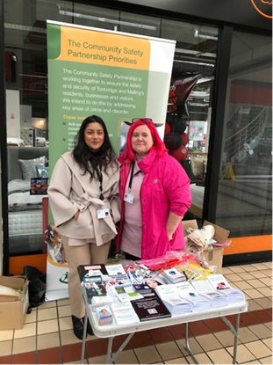

Useful contact details
Community Safety Unit | csp@tmbc.gov.uk | 01732 844522
TMBC ASB Officer | Contact the Borough Council for help with ASB issues | 01732 876149
Kent Police | To report a non 999 call | 101
KCC Community Wardens | Contact Sandra Edmonds, Warden Supervisor | 07969 584183
DAVSS | Offer support for victims of Domestic Abuse | 01892 570538
Lookahead IDVA service | Support for victims of Domestic Abuse | 03330 104660
Victim Support | Support for victims of crime and anyone experiencing domestic abuse | 0808 1689 111
Maidstone Mediation | Support to help resolve conflicts or disputes | 01622 692843
West Kent Mediation | Support to help resolve conflicts or disputes | 01732 469696
Protection Against Stalking | Support for anyone being stalked or harassed | Support@protectionagainststalking.org
Newsletter produced by Tonbridge and Malling CSP
Enquires to Alison Finch, Safer and Stronger Communities Manager, Tonbridge & Malling Borough Council, Gibson Building, Gibson Drive, Kings Hill, West Malling ME19 4LZ, Tel: 01732 844522
Email: csp@tmbc.gov.uk
Twitter: TM_CSP Facebook: Tonbridge and Malling Community Safety Partnership

